**DAILY ONLINE ACTIVITIES SUMMARY**

|  |  |  |  |  |  |  |  |  |
| --- | --- | --- | --- | --- | --- | --- | --- | --- |
| **Date:** | **04/07/2020** | | | | | **Name:** | **Shwetha** | |
| **Sem & Sec** | **8th B** | | | | | **USN:** | **4AL16CS101** | |
| **Online Test Summary** | | | | | | | | |
| **Subject** | | **-** | | | | | | |
| **Max. Marks** | | **-** | | **Score** | | | **-** | |
| **Certification Course Summary** | | | | | | | | |
| **Course** | **AWS certified machine learning speciality** | | | | | | | |
| **Certificate Provider** | | | **AWS** | | **Duration** | | | **4.5hr** |
| **Coding Challenges** | | | | | | | | |
| **Problem Statement:**  **program to find the fibbonnacci series.** | | | | | | | | |
| **Status: Solved**  **Solution link: https://github.com/alvas-education-foundation/Shwetha-** | | | | | | | | |
| **Uploaded the report in Github** | | | | | **Yes** | | | |
| **If yes Repository name** | | | | | **Shwetha-** | | | |
| **Uploaded the report in slack** | | | | | **Yes** | | | |

Certification Course Details:

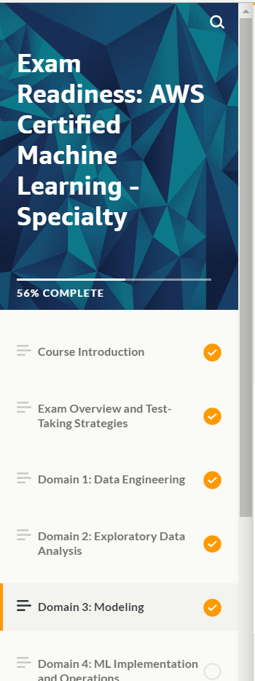

*Coding Challenges Details:*

defrecur_fibo(n):

ifn<=1:

return n

else:

return(recur_fibo(n-1)+recur_fibo(n-2))

nterms=10

ifnterms<=0:

print("Pleseenterapositiveinteger")

else:

print("Fibonaccisequence:")

foriinrange(nterms):

print(recur_fibo(i))